**Advanced GIS Lab 02 Write-Up**

**Arielle Wood**

**1.1.1**

IDW:

Precipitation:

|  |  |  |  |
| --- | --- | --- | --- |
| Nothing Changed | Power changed to 3 | Power changed to 1 | Power changed to 0.5 |
| 0.019756975 | 0.018919019 | 0.06027358 | 0.269406368 |

Temperature:

|  |  |  |  |
| --- | --- | --- | --- |
| Nothing Changed | Power changed to 3 | Power changed to 1 | Power changed to 0.5 |
| 0.210985968 | 0.211944142 | 0.20840194 | 0.516472663 |

Spline:

Precipitation:

|  |  |  |  |  |
| --- | --- | --- | --- | --- |
| Nothing Changed | Weight changed to 0.9 | Weight changed to 0.01 | Points changed to 13 | Points changed to 14 |
| 0.035361815 | 0.037031769 | 0.032107347 | 0.035361815 | 0.035361815 |

Temperature:

|  |  |  |  |  |
| --- | --- | --- | --- | --- |
| Nothing Changed | Weight changed to 0.9 | Weight changed to 0.01 | Points changed to 13 | Points changed to 14 |
| 0.191612467 | 0.172408905 | 0.193329865 | 0.191612467 | 0.191612467 |

Trend:

Precipitation:

|  |  |  |  |
| --- | --- | --- | --- |
| Nothing Changed | Polynomial changed to 2 | Polynomial changed to 0.5 | Polynomial changed to 3 |
| 0.481820116 | 0.306578709 | 0.494395737 | 0.237997273 |

Temperature:

|  |  |  |  |
| --- | --- | --- | --- |
| Nothing Changed | Polynomial changed to 2 | Polynomial changed to 0.5 | Polynomial changed to 3 |
| 0.804054681 | 0.67271138 | 1.415746843 | 0.237221021 |

**1.1.2**

**1. Compare and contrast interpolated precipitation and temperature? What was the RMS error associated with each algorithm using default parameter values? Can you explain why each algorithm produced the magnitude of error it did?**

The IDW produced an RMSE of 0.019756975 for precipitation and an RMSE of 0.210985968 for the temperature. The Spline produced an RMSE of 0.035361815 for the precipitation and an RMSE of 0.191612467 for temperature. The Trend produced an RMSE of 0.481820116 for the precipitation, and an RMSE of 0.804054681 for the temperature.

The IDW algorithm produced error because it is limited by the range of values used. It is an average, so it has a harder time conveying ridges and valleys. The Spline algorithm produced error because the regularized option does better over smoother landscapes, and the regularized option was the default, and was used to cover a mountainous landscape. The trend algorithm produced error because it is dependent on the polynomial order relating equally to the data, and using a default setting increases the likelihood that the algorithm will not fit the data.

**2. Did modification of the input parameters for a specific algorithm modify the RMSE?**

Yes, it can be seen looking at the IDW algorithm. Comparing the RMSE from the default to the IDW with a power of 3, the RMSE decreases making the IDW with a power of 3 the better fit. Comparing the IDW with the power of 3 to the IDW with a power of 1, the RMSE increases significantly. This shows that the IDW with a power of 3 is a better fit than the IDW with a power of 1. Comparing the IDW with a power of 1 to the IDW with a power of 0.5, the RMSE increases significantly. This shows that the IDW with the power of 0.5 is the worst fit for the data. These changes illustrate how changing the parameters affects the algorithm results.

**3. Did different algorithms produce a different spatial distribution of precipitation and temperature? How did you determine if the spatial patterns and magnitudes were different?**

Yes, below are images of the default interpolation results for each algorithm used for both precipitation and temperature. In looking at the images, each algorithm produced a vastly different visual. In comparing the two IDW defaults, it can be observed that the lower half of the precipitation visual is predominately yellow and orange with some green, while the lower half of the temperature visual is predominately red with some orange and no green. These visuals use the same interpolation technique and have vastly different results. By looking at the visuals produced, it is easy to see the differences in the spatial patterns and magnitudes produced by different interpolation techniques.

IDW Precipitation Default:



IDW Temperature Default:



Spline Precipitation Default:



Spline Temperature Default:



Trend Precipitation Default:

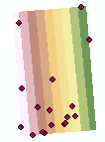

Trend Temperature Default:



**1.2.1**

**Original DEM**

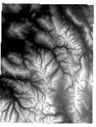

**Shaded relief:**

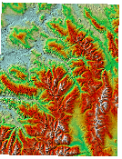

**Resample 90 XY; Nearest Neighbor**

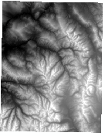

**Shaded relief:**

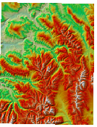

**Resample 90 XY; Bilinear**

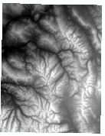

**Shaded Relief:**

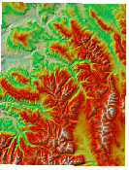

**Resample 90 XY; Cubic**

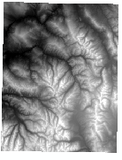

**Shaded relief:**

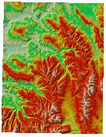

**Resample 150 XY; Nearest Neighbor**

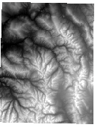

**Shaded relief:**

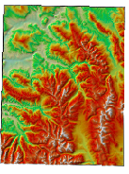

**Resample 150 XY; Bilinear**

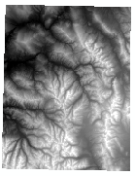

**Shaded relief:**

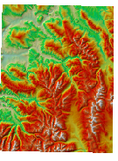

**Resample 150 XY; Cubic**

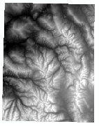

**Shaded relief:**

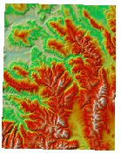

**Resample 250 XY; Nearest Neighbor**

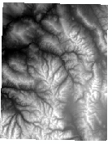

**Shaded Relief:**

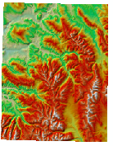

**Resample 250 XY; Bilinear**

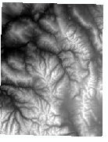

**Shaded relief:**

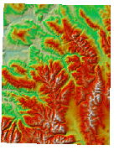

**Resample 250 XY; Cubic**

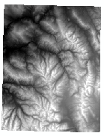

**Shaded relief:**

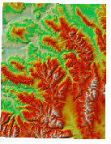

**1.2.2**

**1. Examine the topography at grid cell scales of 30m, 90m, 150m and 250m. You may need to use shaded-relief images to examine the spatial patterns in the topography. Describe how the topography is represented compared to the 30 meter DEM.**

The topography changes slightly through the resampling and the original DEM. The resampling DEMs show land cover close to drainages as yellow or red instead of the green that the original DEM depicts them in. Otherwise, the largest difference is in the pixilation. The original DEM has the best clarity. The 90 m DEM has the second best clarity. The 150 m DEM has poor clarity, as well as the 250 m DEM. The 250 m DEM has the poorest clarity.

**2. Compare and contrast the DEMs at a particular scale that were generated using different interpolation algorithms. Does the type of interpolation algorithm at a particular scale influence the nature of the topography depicted in the shaded-relief representations?**

In looking at the DEM’s at the same scale, a difference cannot be observed between the different types of interpolation algorithms. The type of interpolation algorithm used at a particular scale does not influence the nature of the topography depicted in the shaded-relief representations. The only difference between all of the representations produced was the difference in clarity and pixilation at differing scales.

**3. Compare and contrast the interpolation algorithms that were used to generate topographic profiles. Do this for all three grid-cell scales. Which algorithm is most accurate? How did you determine this?**

The algorithms produced the same statistics and the same visuals. The only difference that can be noted is in the cell scales. The cell scales change and affect the clarity and the pixilation of the visuals produced. The interpolation techniques produced the same visual when compared within the same cell scale.

**1.3.1**

|  |  |  |  |
| --- | --- | --- | --- |
| Method | IDW Power 1 | IDW Power 2 | IDW Power 3 |
|  | 535.5484 | 535.007 | 534.7269 |

|  |  |  |  |  |  |  |
| --- | --- | --- | --- | --- | --- | --- |
| Method | Spline Regularized | Spline Regularized Point 14 | Spline Regularized Weight .9 | Spline Tension | Spline Tension Point 14 | Spline Tension Weight .9 |
|  | 533.64 | 533.3988 | 534.1654 | 533.389 | 533.3448 | 533.5893 |

|  |  |  |  |  |  |  |  |  |  |
| --- | --- | --- | --- | --- | --- | --- | --- | --- | --- |
| Kriging Spherical 12 Pt S.R. | Kriging Circular 12 Pt S.R. | Kriging Exponential 12 Pt S.R. | Kriging Gaussian 12 Pt S.R. | Kriging Linear 12 Pt S.R. | Kriging Spherical 14 Pt S.R. | Kriging Circular 14 Pt S.R. | Kriging Exponential 14 Pt S.R | Kriging Gaussian 14 Pt S.R. | Kriging Linear 14 Pt S.R. |
| 536.0954 | 536.0958 | 536.0198 | 536.29 | 536.1553 | 536.2759 | 536.2965 | 536.1807 | 536.5226 | 536.351 |

IDW Power 1

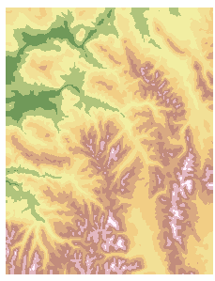

IDW Power 2

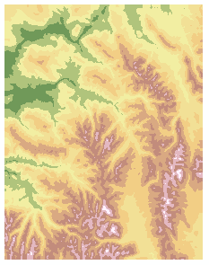

IDW Power 3

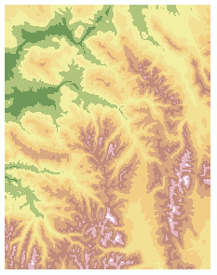

Spline Regularized

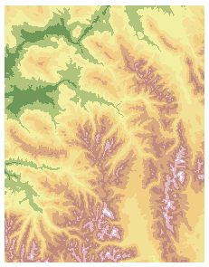

Spline Regularized Point 14

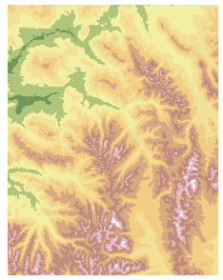

Spline Regularized Weight .9

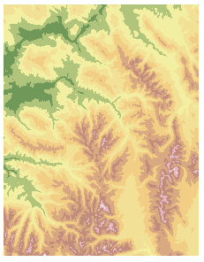

Spline Tension

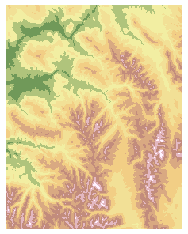

Spline Tension Point 14

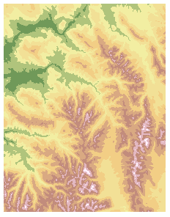

Spline Tension Weight .9

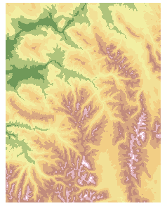

Kriging Spherical 12 Pt S.R.

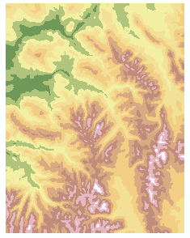

Kriging Circular 12 Pt S.R.

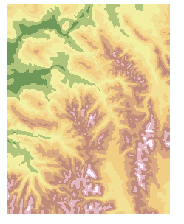

Kriging Exponential 12 Pt S.R.

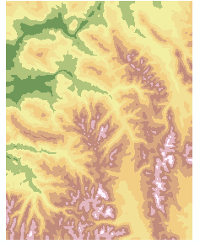

Kriging Gaussian 12 Pt S.R.

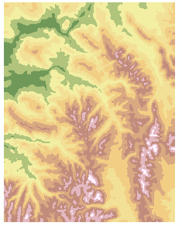

Kriging Linear 12 Pt S.R.

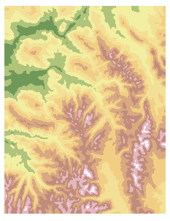

Kriging Spherical 14 Pt S.R.

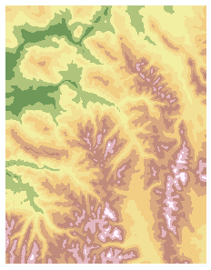

Kriging Circular 14 Pt S.R.

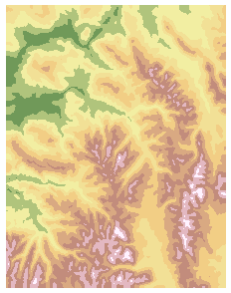

Kriging Exponential 14 Pt S.R.

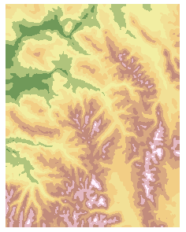

Kriging Gaussian 14 Pt S.R.

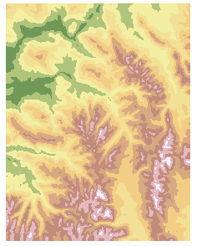

Kriging Linear 14 Pt S.R.

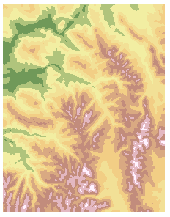

**1.3.2**

**1. Compare and contrast interpolation results using the IDW algorithm. Did the use of different parameter settings influence the results to any degree? Were there differences in spatial patterns? Was there a difference in terms of the global RMSE?**

The use of differing parameter settings changed the visual produced. I changed the power parameter from 2 to 1 and then to 3. Lowering the power from 2 to 1 increased the amount of high elevation shown in red. Raising the power to 3 slightly lessened the amount of high elevation shown in red. I considered the change from 2 to 1 to be the most dramatic of the changes. It showed a very clear change from the land covered in orange becoming land covered in red.

The lower the RMSE, the better the model fit. The IDW with the power parameter set to 3 had the lowest RMSE. It was 534.7269. This is in comparison to 535.007 for the power parameter of 2, and the 535.5484 for the power parameter of 1. Comparing this to the spatial visuals, the visual with the least amount of high elevation land coverage is the interpolation technique with the best model fit to the original DEM.

**2. Compare and contrast interpolation results using the Spline algorithm. Did the use of different parameter settings influence the results to any degree? Were there differences in spatial patterns? Was there a difference in terms of the global RMSE?**

The three main changes in the interpolation technique used were regularized vs tension, the number of points used, and the weight. In comparing the results from the regularized and the tension, only a minimal amount of change can be seen. The regularized spline showed slightly more land cover depicted in green than the tension spline.

The number of points was set to a default of 12. In looking at the regularized spline with 14 points instead of 12, it can be observed that there is a large change in the map produced. The larger number of points caused a large decrease in the land cover shown in green, and a slight increase in the land cover shown in red. Most of the green land cover became orange land cover with the larger number of points.

The default weight setting was .1. In looking at the regularized spline with a weight of .9 instead of .1, it can be observed that there is a significant change in the map produced. The larger weight decreased the amount of land cover shown in red and white, and increased the amount of land cover shown in green.

In looking at the RMSE, the lower the RMSE, the better the model fit. In looking at the numbers, the lowest is the spline tension with 14 points. It has an RMSE of 533.3448. This makes it the best model to use for the data in this instance. The worst fitting model is the spline regularized with a weight of .9. The RMSE for that is 534.1654.

**3. Compare and contrast interpolation results using the Kriging algorithm. Did the use of different parameter settings influence the results to any degree? Were there differences in spatial patterns? Was there a difference in terms of the global RMSE? How do you know what variogram model to use? Do you see a potential problem with this approach if it is based upon only one variogram model (i.e., could the scale-dependent variance structure be different in different locations?)?**

The changes in the interpolation technique used where changing from spherical to circular to exponential to Gaussian to linear, and then changing from 12 point search radius to 14 point search radius. In looking at potential changes between the semivariogram models, there is no visual change in the map produced when changing the model type. In comparing the changes in the search radius, there is a slight difference to be noted in the map produced. The land cover in both the green and the red change slightly in their shape. They maintain about the same amount of land covered, but slightly differ in where the coverage is.

In looking at the RMSE, the lowest RMSE can be determined to be the exponential semivariogram model with the 12 point search radius. It had an RMSE of 536.0198. This means it is the best fit model for the data supplied. The worst fit model is the Gaussian semivariogram with the 14 point search radius. It had an RMSE of 536.5226. I would use the exponential semivariogram model because it had the lowest RMSE. The issue with this model is that it is not always the best model to use. It works for this data, but it may not be the best to use for other types of data.

**4. Which algorithm produced the best results? How did you determine this?**

The spline algorithm produced the best results. It consistently had the lowest RMSE. The average RMSE for the spline was around 533. The average RMSE for the IDW was around 535, and the average RMSE for the kriging was around 536. The lower the RMSE, the better the model fit.

**5. If the sampling of the points from the original DEM were further away from each other, do you think that the same algorithm would produce the best results? If you think this is so, would you use the same parameters? If not, explain why?**

No, the sampling distance plays a significant role in each of the interpolation techniques. They all vary and depend on the sampling distance. If the sampling distance were to differ, the algorithm producing the best results would differ in the RMSE, and its effectiveness to characterize the data.

**6. Knowing what you now know, how would you produce the best interpolation results for the climate data that you worked with earlier (don’t do the work, just describe what you would do differently). Be sure to justify the reasons for your decisions?**

I would have changed the spline type for the spline interpolation. The regularized option is better suited for flatter topography, and was thus, not well suited for the data supplied. The tension option would have better characterized the data. For the trend, I would have changed the type of regression to find the parameters to maximize the fit of the algorithm to the data. These changes would have produced better fitting data because they would cause the parameters to better fit the data supplied.

**2.1.1**

|  |  |  |  |  |
| --- | --- | --- | --- | --- |
| **DEM** | **Min** | **Max** | **Mean** | **St. Dev.** |
| Original | 1896 | 4396 | 3017.4768284632 | 471.49630654253 |
| 90 Bilinear | 1896 | 4396 | 3017.48175879495 | 471.4983894964746 |
| 90 Cubic | 1896 | 4396 | 3017.48175879495 | 471.4983894964746 |
| 150 Bilinear | 1896 | 4384 | 3017.482386668803 | 471.4719488630264 |
| 150 Cubic | 1896 | 4384 | 3017.482386668803 | 471.4719488630264 |
| 250 Bilinear | 1899 | 4366 | 3017.449696707956 | 471.4820632359444 |
| 250 Cubic | 1898 | 4366 | 3017.442610078326 | 471.5007433902938 |

|  |  |  |  |  |
| --- | --- | --- | --- | --- |
| **Hillshade** | **Min** | **Max** | **Mean** | **St. Dev.** |
| Original | 0 | 254 | 171.4819469325826 | 41.80161969844974 |
| 90 Bilinear | 0 | 254 | 173.1074217369969 | 37.91992177692696 |
| 90 Cubic | 0 | 254 | 173.1074217369969 | 37.91992177692696 |
| 150 Bilinear | 0 | 254 | 174.2589512611435 | 34.94012651329997 |
| 150 Cubic | 0 | 254 | 174.2589512611435 | 34.94012651329997 |
| 250 Bilinear | 8 | 254 | 175.7150537278927 | 30.91535445818208 |
| 250 Cubic | 8 | 254 | 175.7053661762282 | 30.94334434102924 |

**2.1.2**

**1. To what degree does the grid resolution influence the magnitude of the statistics? Provide examples and explain the reasons for your results.**

The grid resolution differences are 30m, 90m, 150m, and 250m. For the DEM resampling data, the minimum remains the same for most of the grid resolutions, and only changes within the 250m resolution. The 250m grid resolution causes the minimum to change from 1896 to 1899 for the bilinear interpolation, and to 1898 for the cubic interpolation. The maximum remains the same for the 30m and the 90m grid resolutions. It changes from 4396 to 4384 for the 150 grid resolution. It changes again for the 250m grid resolution, it changes from 4384 to 4366. The mean increases slightly for the 90m grid resolution. It increases again from the 90m resolution to the 150m resolution. From the 150m resolution to the 250m resolution, the mean decreases. It goes from 3017. 482386668803 to 3017.449696707956. The standard deviation increases slightly from the 30m resolution to the 90m resolution. It, then, decreases from the 90m resolution to the 150m resolution. From the 150m resolution to the 250m resolution, the standard deviation increases. The differences noted are predominately seen when the grid resolution changes. The results are typically the same for differing interpolation methods within the same grid resolution. This shows that the grid resolution has a larger impact than the interpolation method.

**2. To what degree does the resampling interpolation method govern the differences in the magnitude of the statistics? Provide examples and explain the reasons for your results.**

The resampling interpolation method only loosely governs differences in the magnitude of the statistics. Most of the changes in numbers occur when the grid resolution changes. The methods with the same grid resolution turn out the same numbers. The only exception to this occurs at the 250m grid resolution. The bilinear interpolation method produces a higher mean of 175.7150537278927, and a lower standard deviation of 30.91535445818208 than the cubic interpolation of 30.94334434102924. This is the only time when a difference between interpolation methods occurs. This shows that the interpolation method only minimally affects the differences in the magnitude of the statistics.

**2.2.1**

|  |  |  |  |  |  |
| --- | --- | --- | --- | --- | --- |
| **Point #** | **1** | **2** | **3** | **4** | **5** |
| **Aspect 30m** | 171.87 | 135.881 | 246.801 | 300.651 | 149.323 |
| **Aspect 90m Bilinear** | 159.404 | 154.855 | 274.764 | 308.367 | 151.894 |
| **Aspect 90m Cubic** | 159.404 | 154.855 | 274.764 | 308.367 | 151.894 |
| **Aspect 150m Bilinear** | 258.486 | 137.979 | 241.928 | 309.85 | 147.355 |
| **Aspect 150m Cubic** | 258.486 | 137.979 | 241.928 | 309.85 | 147.355 |
| **Aspect 250m Bilinear** | 228.772 | 160.482 | 257.005 | 319.543 | 241.28 |
| **Aspect 250m Cubic** | 228.814 | 160.004 | 257.005 | 319.53 | 241.887 |
| **Slope 30m** | 22.4151 | 20.9599 | 1.81752 | 14.6568 | 15.9518 |
| **Slope 90m Bilinear** | 13.1129 | 8.55092 | 1.91577 | 14.3102 | 15.4893 |
| **Slope 90m Cubic** | 13.1129 | 8.55092 | 1.91577 | 14.3102 | 15.4893 |
| **Slope 150m Bilinear** | 5.2478 | 17.612 | 1.62295 | 15.4139 | 14.217 |
| **Slope 150 Cubic** | 5.2478 | 17.612 | 1.62295 | 15.4139 | 14.217 |
| **Slope 250m Bilinear** | 3.68969 | 10.4301 | 1.52848 | 14.5156 | 4.75837 |
| **Slope 250m Cubic** | 3.64943 | 10.5197 | 1.52848 | 14.5534 | 4.73129 |

**Aspect 30m**

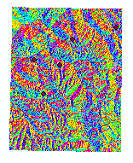

**Aspect 90m Bilinear**

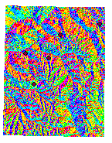

**Aspect 90m Cubic**

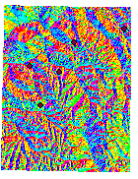

**Aspect 150m Bilinear**

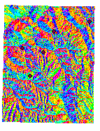

**Aspect 150m Cubic**

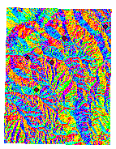

**Aspect 250m Bilinear**

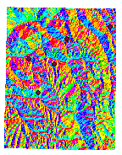

**Aspect 250m Cubic**

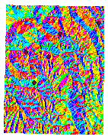

**Slope 30m**

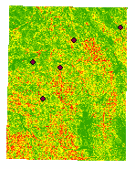

**Slope 90m Bilinear**

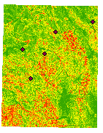

**Slope 90m Cubic**

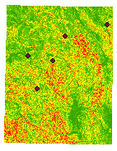

**Slope 150m Bilinear**

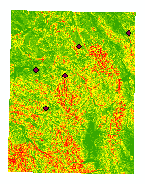

**Slope 150 Cubic**

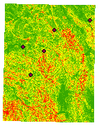

**Slope 250m Bilinear**

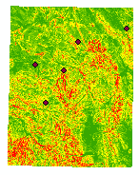

**Slope 250m Cubic**

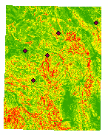

**2.2.2**

**1. Compare and contrast the magnitude of slope angle and slope-azimuth (aspect) values as a function of grid cell size. Are there differences in the magnitude of the values? Do you see any trends? Are the results similar when comparing bilinear and cubic convolution results? Provide examples and explain the reasons for your results.**

For this comparison, I will use values from the first point. The original 30m DEM produced a slope-azimuth of 171.87. Since this was the original/default DEM, I will use it as a reference point. The 90m Aspect caused the slope azimuth value to drop to 159.404. The 150m Aspect caused the slope-azimuth value to significantly increase to 258.486. The 250m Aspect caused the slope-azimuth value to increase to 228.772 for the bilinear and 228.814 for the cubic. There is no significant trend to be seen for the aspect results, but there is a significant trend for the slope results. The higher the resolution for the slope, the lower the slope values becomes. The highest slope value is the default DEM of 22.4151, and the lowest slope value was the DEM with the largest resolution and a value of 2.64943. In comparing the bilinear to the cubic convolution results, I observed that the two methods produced the same or very similar numbers. The only resolution where the numbers differed was the 250m cell size for both the aspect and the slope results.

**2. Compare and contrast the magnitude of slope angle and slope-azimuth values as a function of the resampling interpolation method. Are there differences in the magnitude of the values? Do you see any trends? Do the results vary as a function of grid size? Do the results vary as a function of topographic complexity (i.e., different in different areas of complexity)? Provide examples and explain the reasons for your results.**

Looking at the interpolation method results, the differing interpolation methods produce the same or very similar results. The only example of the results differing slightly is the 250m cell size. Even with this change, the results are still only small decimal places different. They are still very similar numbers. No significant trends can be observed about the nature of the difference between the interpolation methods. The most significant factor in the variance of the results is the cell size.

In comparing the visuals produced, the only notable change between the interpolation methods is in the 250m cell size. The colors slightly shift in some areas. It is a small, but visible change. The nature of the complexity of the topography, however, remains the same despite the slight color shift. The interpolation differences are visible at the 250m cell size because the larger cell size allows for small differences to be seen. The smaller cell sizes do not allow for the slight differences in the interpolation methods to be visible.

**2.3.1**

|  |  |  |  |  |  |
| --- | --- | --- | --- | --- | --- |
| **Point #** | **1** | **2** | **3** | **4** | **5** |
| **Curve 30m** | -1.66667 | -0.66667 | -0.44444 | 0.222222 | 0.111111 |
| **Curve 90m Bilinear** | -0.50617 | -0.79012 | -0.04938 | 0.308642 | 0.283951 |
| **Curve 90m Cubic** | -0.50617 | -0.79012 | -0.04938 | 0.308642 | 0.283951 |
| **Curve 150m Bilinear** | -0.32 | -0.4 | 0.066667 | 0.186667 | 0.186667 |
| **Curve 150m Cubic** | -0.32 | -0.4 | 0.066667 | 0.186667 | 0.186667 |
| **Curve 250m Bilinear** | -0.272 | -0.216 | 0.0064 | 0.0592 | 0.176 |
| **Curve 250m Cubic** | -0.2784 | -0.2064 | 0 | 0.0576 | 0.168 |
| **Tan 30m** | -0.24333 | 0.243836 | -0.90276 | -0.9353 | 0.474147 |
| **Tan 90m Bilinear** | -0.24333 | 0.575693 | 3.17491 | -2.40509 | 0.160935 |
| **Tan 90m Cubic** | -0.24333 | 0.575693 | 3.17491 | -2.40509 | 0.160935 |
| **Tan 150m Bilinear** | 1.7213 | 25.2455 | 2.08758 | -0.18777 | -0.13325 |
| **Tan 150 Cubic** | 1.7213 | 25.2455 | 2.08758 | -0.18777 | -0.13325 |
| **Tan 250m Bilinear** | 0.339939 | 1.9964 | 0.272095 | 1.9964 | -3.16991 |
| **Tan 250m Cubic** | -0.79603 | -1.6849 | -0.90276 | 1.9964 | 1.20079 |

**Curve 30m**

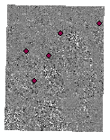

**Curve 90m Bilinear**

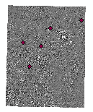

**Curve 90m Cubic**

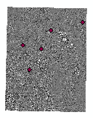

**Curve 150m Bilinear**

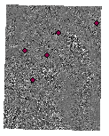

**Curve 150m Cubic**

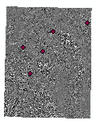

**Curve 250m Bilinear**

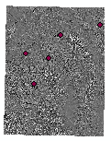

**Curve 250m Cubic**

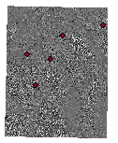

**Tan 30m**

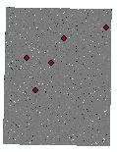

**Tan 90m Bilinear**

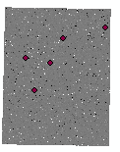

**Tan 90m Cubic**

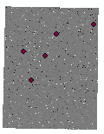

**Tan 150m Bilinear**

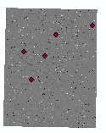

**Tan 150 Cubic**

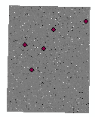

**Tan 250m Bilinear**

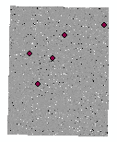

**Tan 250m Cubic**

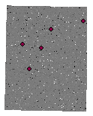

**2.3.2**

**1. Compare and contrast the magnitude of the curvature values as a function of grid-cell size. Are there differences in the magnitude of the values? Do you see any trends? Are the results similar when comparing bilinear and cubic convolution results? Provide examples and explain the reasons for your results.**

The original DEM value for the curvature is the base value for the comparisons. This is because it is the default option. For the curvature, as the cell size increases, the curvature values increase as well. They change from -1.66667 for the default DEM to -.2784 for the 250m cell size cubic interpolation. The trend does not continue for the tangent values. The default value is -0.24333, it remains the same for the 90m cell size. It then significantly increases for the 150m cell size, and only slightly increases for the 250m cell size. The interpolation results are only different for the 250m cell size. The curvature change between the two is very slight, while the tangent change between the two is significant.

**2. Compare and contrast the magnitude of curvature values as a function of the resampling interpolation method. Are there differences in the magnitude of the values? Do you see any trends? Do the results vary as a function of grid size? Do the results vary as a function of topographic complexity (i.e., different in different areas of complexity)? Provide examples and explain the reasons for your results.**

The curvature values for the interpolation methods are the same except for the 250m cell size. The 250m cell size has a minimal change between the bilinear and the cubic interpolation method. The tangent values for the interpolation methods show a larger change. The 250m cell size shows a change from 0.339939 for the bilinear to -0.79603 for the cubic. This is a relatively large change between interpolation methods. No trends between interpolation methods are currently visible when looking at the data.

Looking at the visuals produced, the interpolation methods produce the same visuals except for the tangent 250m interpolation method. The bilinear method with these parameters shows a light grey visual with black and white dots, whereas the cubic method with these parameters shows a dark grey visual with black and white dots. This change is the largest change to be observed throughout the comparisons between interpolation methods.

**3. Based upon your collective experience in doing this exercise, what are your conclusions about the advantages and limitations associated with using spatial interpolation algorithms to characterize the spatial complexity in geospatial data? Be a specific as you can.**

Using spatial interpolation algorithms to characterize spatial complexity is helpful when trying to make a topographic visual to use as a background image, or to use for topography analysis. Overall, it is helpful to use interpolation algorithms. They are, however, limited in their specific use. It is very difficult and time consuming to compare and contrast the interpolation algorithms, and often, data needed for showing their differences is not available. This makes selecting an appropriate interpolation method very difficult and inefficient. The wrong method might produce incorrect information, with almost no way to check the information validity. Interpolation algorithms can be useful for non-specific / detailed use, but can be very limited for detailed and specific use.